**SEEDS OF GOOD HOPE PRIMARY, NURSERY AND DAY CARE**

**END OF TERM III EXAMINATION 2023**

**TOP CLASS: (5 – 6 YEARS)**

**LEARNING AREA 1: SOCIAL DEVELOPMENT**

**My name is: ………………………………..………………………….**

**My School is: ……………………………..……….…………………..**

**I am in: ………………………………..…………………………………………..**

1. **Read and draw.**

|  |  |  |
| --- | --- | --- |
|  |  |  |
| dress | shirt | belt |
|  |  |
| vest | short |

1. **Circle the dangerous objects.**

book tree fire

stone razorblade

nail table pin

1. 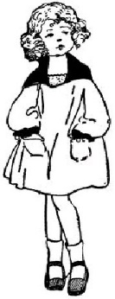**Match sentences to pictures.**

I can see a baby.

D:\Local Disk F\New folder\PRETTIE FOLDER\PRETTIE AND PRECIOUS\BACK-UP\amper aliya\WORK CLEAN\NEW ORGANISED WORK\ACHIEVERS' WORK ALL\ALL diagrampics\diagram 2\mother.tif

This is my father.



That is my bother.

D:\Local Disk F\New folder\PRETTIE FOLDER\PRETTIE AND PRECIOUS\BACK-UP\amper aliya\WORK CLEAN\NEW ORGANISED WORK\ACHIEVERS' WORK ALL\ALL diagrampics\diagram 2\father.tif

Here is my mother.

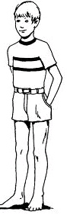

I can see my sister.

1. **Draw these important places**.

|  |  |  |
| --- | --- | --- |
|  |  |  |
| school | church | mosque |

1. **Oral questions.**

i) Who is your friend?

ii) Who is your teacher?

iii) Sing for me any song.

iv) What is your school motto?

v) What is the weather now?

1. **Name three things we use at home**.
2. ________________________________
3. ________________________________
4. _______________________________
5. **Name these domestic animals**.

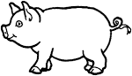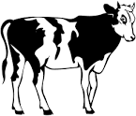

___________ ___________

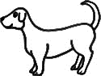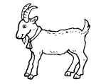

____________ ___________

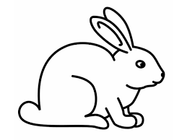

_____________ _____________

***“Good Luck”***